BEAVER’S 30TH BIRTHDAY
badge order form

Use this form to order your front of uniform badges.

Your name

Your group/section

Postal address

Please send me ___x Norfolk Beaver 30th Birthday Badges at £1 each

Send this form with a cheque payable to ‘Norfolk Scouts’ for the total amount including £2 postage and packing to:
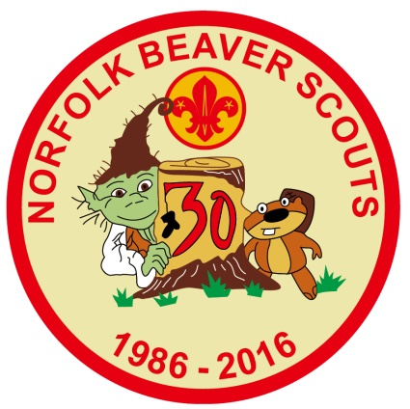
Beaver Birthday Badge Orders
Norfolk Scouts
Eaton Vale Scout and Guide Activity Centre
Church Lane
Eaton
Norwich
NR4 6NN

Orders can be left at the trading post for collection

