GO GO HARE CHALLENGES 2018

badge order form:

Use this form to order your front of uniform badges.

Your name

Your Group/Section

Postal Address

Please send me ___ Norfolk Go Go Hares Challenge Badges @£1.00 each.

Please send this form with a cheque payable to ‘Norfolk Scouts’ for the total amount, plus £3.00 postage and packing to:

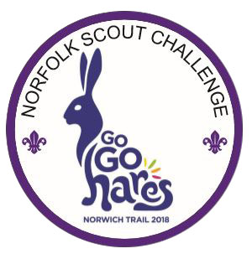
Go Go Hares Badge Orders
Norfolk Scouts Trading Post
C/O Eaton Vale
Church Lane
Eaton
Norwich
NR4 6NN

