Matchstick Fun and Games

Low-cost five-minute fillers for all sections.

What can you do with a box of matches other than light a fire?
Here are some traditional puzzles to challenge any age, from Beavers to Networkers.

Swimming Fish…
Move two matches to make the fish swim in the opposite direction.
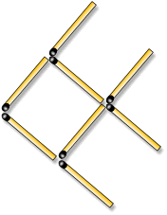 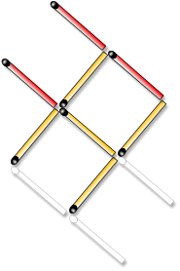 Set Up (8 matches) Solution

Two Squares to Three…
Move four matches to make three squares.
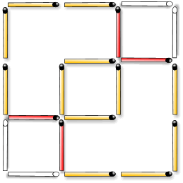
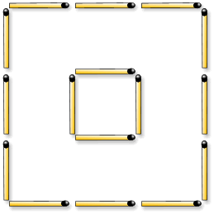

Set Up (16 matches) Solution

Turning the Donkey….
Move one matchstick to turn the direction of the donkey.
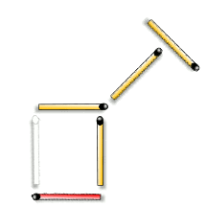
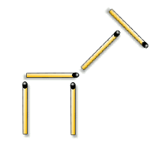

Set Up (5 matches) Solution

“Non-strike” match sticks are a good alternative to using real matches and are available from craft suppliers.

Three Squares into Five…
Move six matches so that five squares are made.
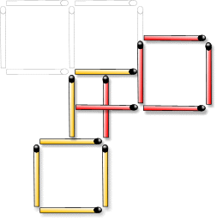
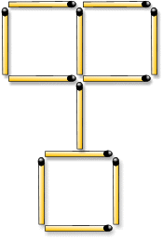

Set Up (12 matches) Solution

Three into Six…
This one is for the older sections only – no clues allowed.
Make three matches into six (no breaking of the sticks).

Set Up (3 matches) Solution

Or Alternatively Make a Model….
