NORFOLK SCOUTS PROGRAMME TEAM CHALLENGE

We can tell that many of your enjoyed the County Set Challenges in 2016
Following feedback, we have created a set of 3 really simple challenges to help stretch your programmes and add a bit of fun this year
Participation is voluntary but any Section that completes all 3 Challenges will be recognised with a small trophy and certificate.
Badges are available for each challenge. These are small pin non-uniform badges that can be placed on camp blankets or worn when you are out of uniform to prompt conversations about Scouting.
Participation is free and when a challenge is completed, all we ask is that you send a brief written submission to the team email box – provdev@norfolkscouts.org.uk or, if you wish to post and share, feel free to do so on Norfolk Scouts Sharing Centre.
Following the submission of your evidence, please send your completed badge order form into County Office together with a secure stamped self-addressed envelope (making sure you allow for sufficient postage) and we will send you your badges. These can be done after all the challenges or one at a time.
We are all looking forward to hearing from you and your stories and successes.
Jane
Jane Warden
Deputy County Commissioner – Programme

The team: - Tim Rowe (Admin) Tony Millburn (ACC Cubs) Trevor Orford (ACC Scouts) Tom Hadley (ACC 14-25) Matt Kitchin (QSA/Explorer Belt) Louy Howes (Special Projects), Sue Bisley (DOE Admin) Colin Scott (Acting DOE Manager)

challenge 1 - bring a friend night (to grow the group) or bring a parent night (to recruit volunteers)

Plan and run a night or event either for the young people to bring a friend or ask them to bring a parent/carer.
Bring a Friend Night – things to consider
Run a fun programme for the evening with elements from each of the programme zones with the aim of giving the young people a full taster of what scouting can offer.
When planning your activities, remember you may have more young people than usual at your meeting, so consider space; adult to young people ratio; and risk assessments.
When invites are sent out for the evening/event, please also send an emergency contact form and request that your visiting young people bring it with them on the evening of the event.
Tip: If you plan to give out badges on the evening, don’t forget to order your badges in plenty of time and enough to give one to each friend too. You are welcome to keep or return any if you over order.

Bring a parent/carer night – things to consider
Run a fun programme for the evening with parts from each of the programme zones to give the parents/carers a taster of what the young people do in scouting.
Include them in everything – such as placing them alongside the young people for the opening ceremony; involving them in all activities; or ask them to join in with any games you run. Consider any games you are playing to ensure these are suitable for all.
Please also consider child protection and ensure no parent is put into a one to one situation with a young person.
Tip: take time to chat with visiting parents/carers to get their feedback. Perhaps ask them to join the parent/carer rota (remember requirements of CRB checks in the PoR), especially those who appear to have fully embraced the evening and shown a real interest in scouting. Who knows where it could lead……

Please share your stories and success to prodev@norfolkscouts.org.uk or Norfolk Scouts Sharing Centre
In respect of challenge 1 – if you wish for the badges to hand out at the end of the meeting/event, please send in your form along with your stamped addressed envelope, giving sufficient time, and these will be sent out to you in advance of the meeting/event. (Remember friends get a badge too!)

challenge 2 - share scouting in your community (to grow the group and recruit volunteers)

This challenge involves running an event in your local community.
Some examples are:
- Taking part in something such as a carnival or taking part in a display (i.e. tent pitching) at a local fete.
- Running a stall at a local fete; garden show; or open day.
- Running an activity at your own scouting event in your community.
- Offer garden maintenance, bag pack; a gang show at a residential care home; or help decorate a local community centre.
The possibilities are endless. For those who already do these or have being doing the same event for years, why not share what you do with others on the Norfolk Scouts Sharing Centre. We also challenge you to do something different - you may be surprised!

Things to remember:
There are banners and pop up stands available for you to borrow for your event – please book them with Karen @ County Office – email hq@norfolkscouts.org.uk
Please consider all elements of health and safety and risk assessments.
Have a supply of leaflets to hand out about scouting – these can be made and personalised form the Print Centre or you may have your own Group Information Cards.
Tip: Have a supply of ‘want to join forms’ (see template within this pack) suitable for both young people and adult volunteers. Encourage people to complete the information there and then rather than take the forms away. Please follow up completed forms within 7 days. If you received completed forms that are not local enquiries for your own group, please email the information across to the team mail box – prodev@norfolkscouts.org.uk and we will forward it on.

Please share your stories and success to prodev@norfolkscouts.org.uk or Norfolk Scouts Sharing Centre

challenge 3 - take your scarf to an unusual place (shouting about scouting)

This challenge is all about wearing your scarf with pride and getting it seen in the Community
Some suggestions are:
- Take you section on a trip and take a picture of your scarfs in an unusual location.
- Go on a camp or sleepover, take a picture of you all in your scarves and share where you are and why you enjoyed it.
- Individuals in the group may want to take their scarves on holiday and take a picture.
- Perhaps encourage leaders to complete a sponsored “wear you scarf for work day”.

With your section – using a map of the UK or the world, plot the locations of who has taken their scarves where and share stories. Even better, share any comments they received for wearing their scarf.
We want to see how far scarves from Norfolk Travel and where in the world they end up

Please share your stories and success to prodev@norfolkscouts.org.uk or Norfolk Scouts Sharing Centre

Appendices:

1 – badge order form
2 – sample want to join form

programme team challenge 2017
badge order form
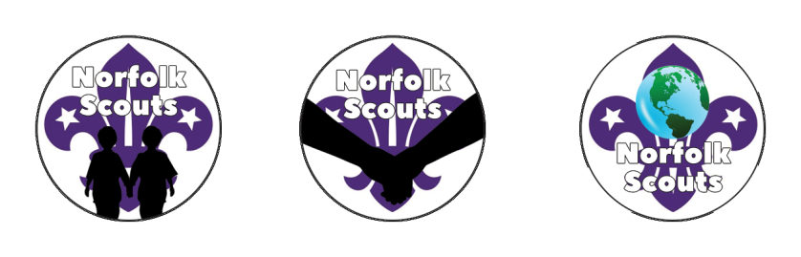

Your name

Your group/section

Contact email address

Badge requested | Challenge 1/Challenge 2/Challenge 3
Number of badges requested

Don’t forget to include a stamped addressed envelope with enough postage on it - Tip: 10 badges will travel fine as a large letter (up to 100g – 96p) but anything over this – you may wish to refer to the small package rates: 20 badges (up to 250g £1.27); 50 badges (up to 500g £1.71).
Send this form to :
Programme Team Challenge 2017
Norfolk Scouts
Eaton Vale Scout and Guide Activity Centre
Church Lane
Eaton
Norwich
NR4 6NN

Want to know more information about Scouting?

please complete the form below and you will be contacted within 7 days to provide you with further information

Name

address

contact email address

contact telephone number (if prefer to email)

young person or adult? *If young person please complete details below
young persons name
date of birth
section to join

If you are unable to complete this on the day and would like further information please visit www.norfolkscouts.org.uk or email pro.dev@norfolkscouts.org.uk

