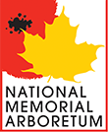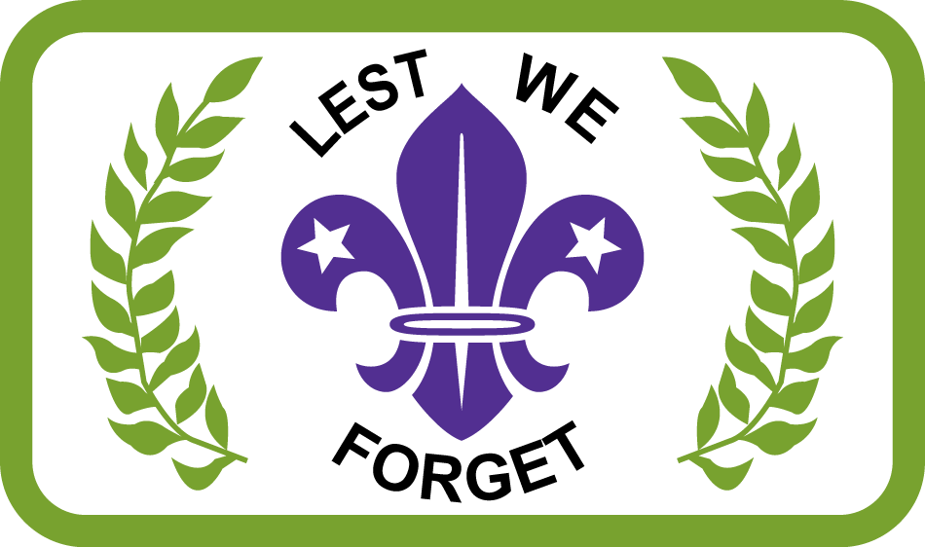

COACH TRIP TO VISIT THE SCOUT MEMORIAL
SATURDAY 20th MAY 2017.

An adults only coach trip will depart Great Yarmouth and Norwich (Eaton Vale) at approximately 06:00 & 06:30 & journey to the National Arboretum, located near Birmingham, in time to join in the “Last Post Ceremony”.
You will then have plenty of time to tour the memorial fields including the memorial to fallen Scouts that was unveiled last year – a truly splendid tribute.
We will leave the Arboretum around 15:30, stopping on the way home
for a chance to enjoy some refreshment, & arrive home for 20:00 ish.
The cost including a 50-minute Train Tour around the Arboretum is £35.

Completed forms should be sent to County Office by the 15th May, together with a cheque for £35 per person payable to Norfolk County Scout Council to confirm places.

Name: ________________________________________________

Telephone: _____________________________________________

Email: _________________________________________________

No: of places required ________ at £35 per person

Cheque enclosed for £ ____________ payable to Norfolk County Scout Council

