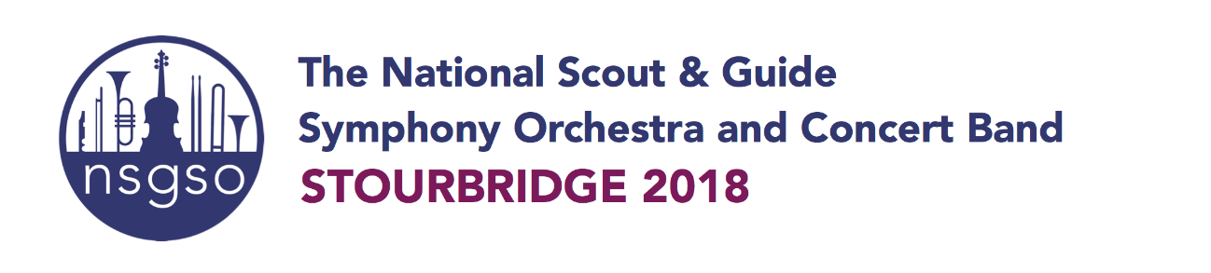

We are really pleased to announce that applications for the 2018 NSGSO course are now open. **We are taking applications for both the Orchestra and the Concert Band.** The closing date is midnight on Saturday 16 December. I would be really grateful if you could ensure that this email and flier are circulated as widely as possible amongst young people aged 12-25 in your county, district, group or unit. To that end please can you circulate to all Scout, Explorer and Network leaders and members.

Last year 128 young people attended - a record year again and we hope to take even more in 2018. The course and concerts are based in Stourbridge, West Midlands and runs from **Sunday 29 July - Sunday 5 August 2018**. The course is hosted by Birmingham Scout County in conjunction with Girlguiding Birmingham.

**NSGSO Orchestra and NSGSO Concert Band**

The Orchestra is now in its 43rd year, and after the success of forming the Concert Band two years ago it will again be run alongside the Orchestra. So there is a choice of 2 ensembles to apply for. There is slightly different criteria for each - please see below and also our website for specific information.

**The NSGSO Course**

The NSGSO meets every year for a fantastic week's course of music and social activities led by 12 professional tutors and 2 conductors, and hosted by 8 staff members. During the week the Concert Band will perform 2 concerts in the community and also their main Saturday lunch time concert on 4th August. They will also have the opportunity to take part in the two concerts with the Orchestra as guest artistes. For the Orchestra the week will culminate in two evening concerts in Birmingham on Friday 3rd and Saturday 4th August with the Concert Band as guest artists. Both the Orchestra and the Concert Band will also play a joint piece together at the Friday and Saturday evening concerts. Alex Peace Gadsby, England Commissioner is already booked to attend both the concerts on  Saturday 5th August. To see for yourself what the NSGSO course involves watch our short promotional film  [NSGSO Promotional Video](https://youtu.be/nji1ALz1Jm0)

**Our aim is to make sure that this email and flier reaches as many young people as possible so please could you circulate.**

**The NSGSO had its 40th anniversary concert in 2015 but we are still not as widely known as we would like. Please could you circulate this email via email/Facebook groups/county websites/tweet etc. We would be most grateful.**

To **apply** for the 2018 NSGSO Course for both the Orchestra and Concert Band and to find out lots more detail go to[**apply.nsgso.com**](http://apply.nsgso.com/)**.** The application form is on the bottom of the home page

**For the Orchestra all applicants must be:**   
- A Member of the The Scout Association or Girlguiding.   
- Aged 13-25 by 31 August 2018  
- Proficient player of a least one orchestral instrument (Grade 5 or above)

*Please note:*

*1. String players who are Grade 4 may be accepted under certain circumstances.  
2. Applicants between the ages of 26-30 will be considered in the event that a section is under-subscribed.*

**For the Concert Band all applicants must be:**

 - A Member of the The Scout Association or Girlguiding.   
- Aged 12-25 by 31 August 2018  
- Proficient player of a least one concert band instrument (Grade 4 or above)

Details of all instruments are on the website at apply.nsgso.com

**Further Information**

The cost of the course has been increased by just £5 since last year to £495, payable in four instalments. The course cost includes full board, accommodation, rehearsals and workshops with a professional conductor and sectional tutors, uniform for new members, transportation during the week and social activities. You just need to transport yourself to Stourbridge and after that everything else is paid for. We can pick you up from Stourbridge station or Birmingham airport.

For help with funding applicants should contact their group first, then district and then county. Applicants can of course do their own fundraising for this event. We can help you with contact details if you would like to email. It is highly likely that there will be NSGSO bursaries again for 2018. Please email me if you would like more information.

For anyone wishing to use this course for their DofE, QSA or QGA residential then this year must be the first time that they have attended.

Please do email me at [jill@nsgso.com](mailto:jill@nsgso.com)with any queries that you have.

The closing date is midnight on Saturday 16th December

Thank you,    
  
**Jill Bowman**

**NSGSO Manager**

**The National Scout & Guide Symphony Orchestra**

[**jill@nsgso.com**](mailto:jill@nsgso.com)

