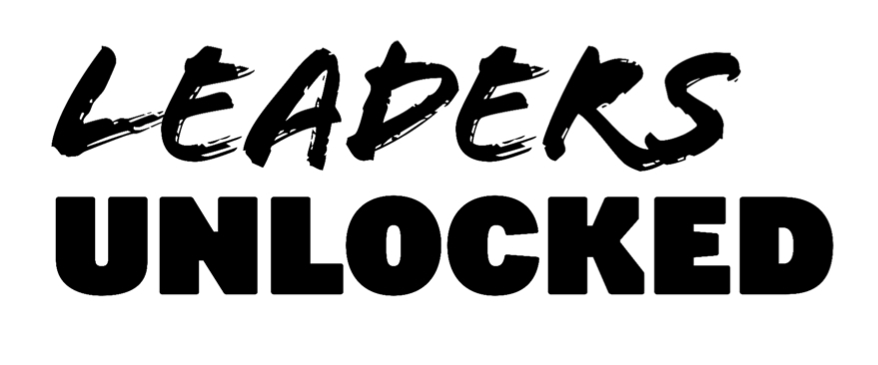
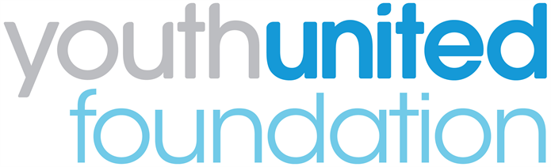

Youth United Panel 2018
Parent/carer consent form
If you are under 18, please ask a parent/guardian/carer to complete and sign this form to confirm their consent for your participation.

I consent to [name] …………………………………………………………………………… becoming a member of Youth United Panel from March to June 2018.
Parent/guardian name (print):……………………………………………………………….....
Parent/guardian signature……………………………………………………………………….

Relationship to applicant: ………………………………………………………………………
Date: ………………………………………………………………………...............................
Contact telephone number: ……………………………………………………………………
Email: ……………………………………………………………………………………………
This form can either be submitted at the first event or scanned and emailed to kaytea@leaders-unlocked.org

