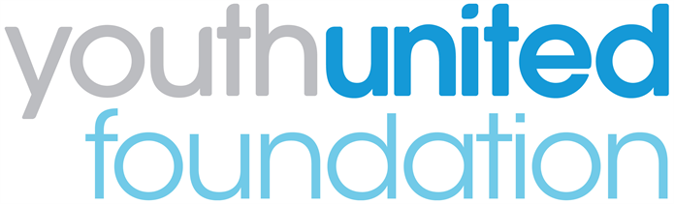

Youth United Panel: Application Form

We are looking for applications from 14-24 year olds who are currently involved with uniformed youth groups – including Air Cadets; Army Cadet Force; The Boys' Brigade; Fire Cadets; The Girls' Brigade England & Wales; Girlguiding; Jewish Lads' and Girls' Brigade; The Scout Association; Sea Cadets; St John Ambulance and Volunteer Police Cadets.

Section 1: your details

Name:

Date of birth:

Home address:
Postcode:
Email:
Landline:
Mobile:

Uniformed youth group:

Named group leader who will support your application:

If you are under 18 years old, please ask your parent/guardian/carer to provide the following details too. We will require written permission from them.

Name of parent/guardian/carer:
Home address:
Postcode:
Email:
Landline:
Mobile:

Section 2: more about you

- Why do you want to join the Youth United Panel?

- Why do you think you should be selected for the Panel?
For example, you might have specific skills, knowledge or life experiences that you’d like us to know about.

- Please tell us about yourself. Use up to 50 words to sum up your personality, interests or strengths. (Please stay within the word limit.)

Section 3: your availability

We will be holding the first Panel event on Saturday 17th March 2018 in London. Your travel will be paid for.

Are you available to attend? Yes [ ] No [ ]

Section 5: diversity monitoring information

Leaders Unlocked is committed to promoting equality and diversity. We ask you to complete this form so that we can monitor and analyse information about the diversity of the people who submit an application. Any information you provide will be treated as strictly confidential. It will not be used by anyone directly involved in the selection process. We will transfer all the information provided into a database and then destroy all individual forms. No information will be published or used in any way that allows any individual to be identified. You are not obliged to answer the questions on this form. If you do not wish to answer a question simply answer ‘Prefer not to say’.

- Your gender (please put an tick in the appropriate box)

Male Female Third gender/other

Prefer not to say

- Your sexual orientation (please put an X in the appropriate box)

Bisexual Gay man Gay woman/lesbian

Heterosexual Other Prefer not to say

- Your religion or belief (please put an X in the appropriate box)

None Buddhist Christian

Hindu Jewish Muslim

Sikh Any other Prefer not to say

- Your ethnic origin (please put an X in the appropriate box)

White

British English Welsh Scottish

Northern Irish Gypsy or Irish Traveller Other

Mixed/multiple ethnic background

White and Black Caribbean White and Black African

White and Asian Any other/ multiple ethnic background

Asian/Asian British

Bangladeshi Chinese Indian Pakistani

Any other Asian background

Black/African/Caribbean/Black British

African Caribbean

Other Black/African/ Caribbean background

Other ethnic group

Arab Any other ethnic group Prefer not to say

- Do you consider that you have a disability?

Yes No Prefer not to say

Section 6: when will I hear back?

Please email your application form back by Monday 12th March 2018 to kaytea@leaders-unlocked.org

We will conduct brief interviews with shortlisted candidates on the phone. All applicants will be informed of the decision by 15th March 2018.
If you have any other questions, please email kaytea@leaders-unlocked.org

We look forward to receiving your application!

