From Major Louise J Henderson

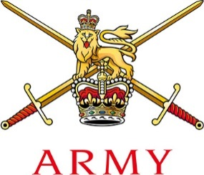 | SO2 Youth Engagement  Civil Engagement Branch  Headquarters Regional Command,  Montgomery House, Queens Avenue,  Aldershot, Hampshire, GU11 2JN  Tel 01252 347536 Military 94222 7536  E-Mail louise.henderson827@mod.gov.uk
Dear County Commissioner

Scout Mechanic Activity Badge

Following the launch of the British Army’s sponsorship of the Scout Mechanic Activity Badge, we would love to work with you to help your Scouts complete their badge. As part of our sponsorship, we are putting Scout groups across the United Kingdom in touch with their local Regiments and smaller units. Subject to levels of demand, the aim is to arrange a session locally – either in your Troop location or on one of our bases – at which some of our soldiers will bring the vehicles and kit. Your group will then be able to complete the Scouts Mechanic Activity Badge requirements on our Army vehicles, whilst under the expert guidance of the Army! We ran a very successful pilot event at MoD Lyneham in April 2018, at which 300 Scouts completed their Mechanic Activity Badge.

We are scheduling activity for the next year now and so we would be grateful if you could forward the information on to your District Commissioners and Scout Leaders. Any bids for activity or queries should be directed to me.

We look forward to working with you.

Kind Regards,

Louise Henderson

