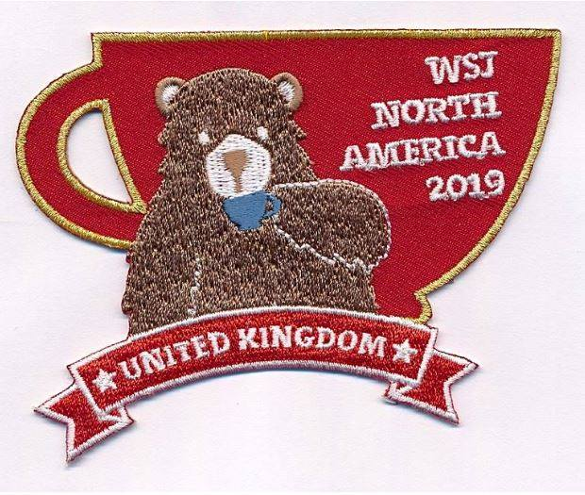
24th World Scout Jamboree 2019 –
UK Contingent Supporters Badges
The United Kingdom Jamboree Contingent has produced a rather spectacular Supporters badge to celebrate the 24th World Scout Jamboree and Matthew Burrell (County Commissioner) has very kindly allowed the wearing of this rather spectacular badge (Featuring the now famous TEABEAR) on uniform of all the members of Norfolk Scouting including young people
At the 24th World Scout Jamboree over 40,000 scouts from all over the world will come together to share the magic that is World Scouting. I am attending the Jamboree as part of the 750 strong International Service Team and will be working on of the many subcamps occupied by the jamboree participants whilst at the jamboree.
HOW TO ORDER YOUR BADGES
Decide how many you want.
- Take the number of badges x cost of a badge (£2.00 EACH)
- Add cost of postage depending on order size (costs as follows)
1 – 4 Badges | 56p
4 and above | 79p

- Make your payment using either of the following methods
BACS – Sort Code 404763 Account Number 65424666
In the Reference section please insert Your Surname or Group
Or
PAYPAL - paypal.me/rickcooper24thWSJUSA
- Once completed email rickcooper24thwsjusa@gmail.com and let me know the following information

- Your Name
- Your Postal Address, including Postcode
- Telephone number
- Number of badges required
- Postage rate required (see above)
- Total payment made
- PayPal transaction reference
All profits made go to support those members of Norfolk Scouting attending the 24th World Scout Jamboree going as members of the international Service Team.
Thank you for your support

Rick Cooper
UK Contingent International Service Team
24th World Scout Jamboree

