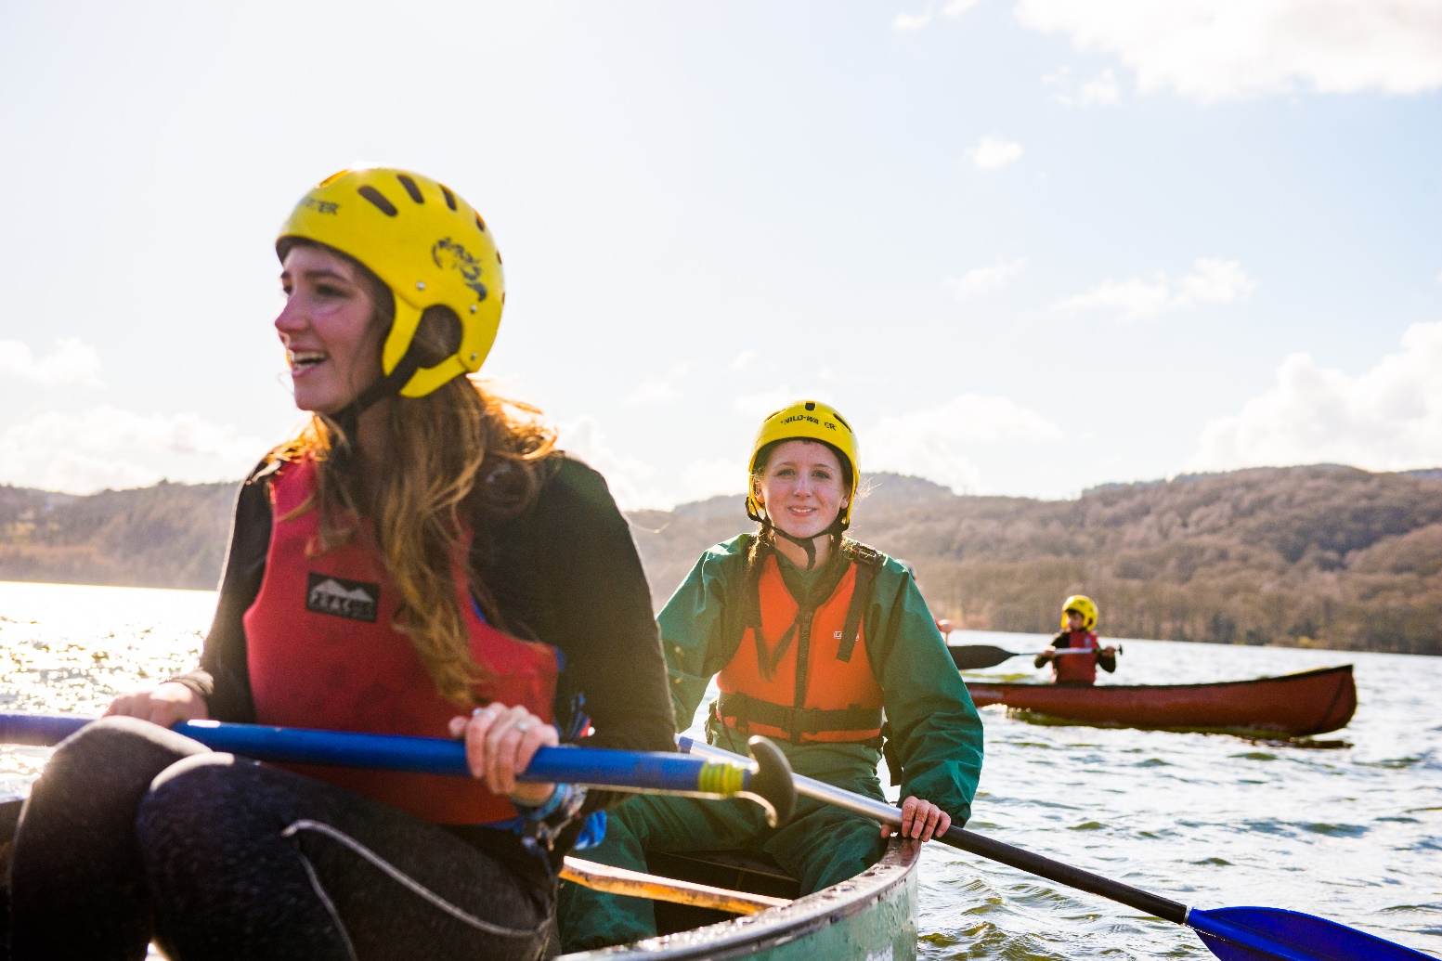
District Commissioner

We’re looking for a new lead volunteer for Eastern Norwich.

About the Scouts
Overview of Scouting
We are the UK’s biggest mixed youth organisation. We change lives by offering 6 to 25 year olds fun and challenging activities, unique experiences, everyday adventure and the chance to help others so that we make a positive impact in communities.
Scouts helps children and young adults reach their full potential. Our members gain valuable skills for life including teamwork, time management, leadership, initiative, planning, communication, self-motivation, cultural awareness and commitment. We help young people to get jobs, save lives and even change the world.

What do Scouts do?
Scouts take part in a wide range of activities as diverse as kayaking, abseiling, expeditions overseas, photography, climbing and zorbing. As a Scout you can learn survival skills, first aid, computer programming or even how to fly a plane. There’s something for everyone. It’s a great way to have fun, make friends, get outdoors, express your creativity and experience the wider world.

What do volunteers do?
This everyday adventure is only possible thanks to our team of adult volunteers, who support Scouts in a wide range of roles from working directly with young people, to helping manage a local community based Group, to being a charity Trustee. We help volunteers get the most out of their experiences at Scouts by providing opportunities for adventure, training, fun and friendship.
Our award winning training scheme for volunteers means that adults get as much from Scouts as young people. Our approach focuses on what you want to get out of volunteering with Scouts, while respecting how much time you can offer. Over 90% of Scout volunteers say that their skills and experiences have been useful in their work or personal life.

Key facts and figures
The Scout Association is a UK charity founded in 1907 and now boasts a membership of over 620,000 young people and adult leaders. We are the largest mixed youth movement in the UK. Scouting activity is delivered through 7,000-plus community based Scout Groups nationwide.
Scouting is widely recognised and is one of the most trusted charities in the UK, giving it a significant level of influence and responsibility. Scouting’s greatest strength lies in its grass roots. It is locally that Scouting is best able to identify and work directly with young people most in need.
We believe that through the everyday adventure of Scouting, young people and adult volunteers regularly experience new challenges that enrich and change their lives.
The current focus for the Trustees and those in Scouting in the UK is delivering our strategic vision.

Our strategy
We have a strategic plan for Scouting across the UK.
Our plan is to build on our success to continue to grow, become more inclusive, to be shaped by young people and to make a bigger impact in our communities.
We originally set goals for achieve by 2023.
Because of the impact to Scouting of the pandemic we’ve extended our existing plan to 2025 and added extra elements to focus on rebuilding follow Covid-19.

By 2025 we will have prepared more young people with skills for life, supported by amazing leaders delivering an inspiring programme. We will be growing, more inclusive, shaped by young people and making a bigger impact in our communities.
Further information on our strategic objectives are provided on our website at Skills for Life | Scouts

Scouting’s fundamentals

Our mission
Scouting exists to actively engage and support young people in their personal development, empowering them to make a positive contribution to society.

Our values
As Scouts, we are guided by these values:

Integrity

Respect

Care

Belief

Co-operation
Further information on our fundamentals, including details of our values, are provided on our website at Fundamentals of Scouting | Scouts

Scouting’s key policies
In common with all members in Scouting, District Commissioners are required to promote and follow our key policies. The policies cover:

Development

Equal Opportunities

Privacy and Data Protection

Religion

Safety

Safeguarding

These policies are fully explained on our website at Chapter 2: Key Policies | Policy, Organisation and Rules | Scouts

Eastern Norwich Scouts

Summary
Eastern Norwich Scout District is a vibrant Scouting community that has a mixture of Groups in rural and urban areas. Although geographically the smallest District in Norfolk it has tradionally had one of the largest populations of young people and adults.
The District was formed in in the early 00s and following a period of short term, or acting Disitrict Commissioners, the current Commissioner was appointed in 2015. During the time that has passed the Disitrict Team and Executive has built and modernised.
With the clear leadership of the Disitrict Commissoner and his team the Disitrict has united and grown and now provides quality programme both in Group and Disitrict settings. The current commissioner has decided that the time is right now for a new challenge in Scouting as for someone else to bring new ideas and visions to take the District for the next few years.

The Groups
Eastern Norwich Scout Disitrict is located within Norfolk County, and is made up of 12 Groups.
- 1st Blofield and Brundall
- 2nd Brundall
- 1st Great and Little Plumstead Sea Scouts
- 1st Lingwood/Strumpshaw
- 8th Norwich (Norwich School) Sea Scout Group
- 15th Norwich – Plumstead Road
- 17th Norwich (St.George’s Catholic) – Wroxham Road
- 29th Norwich (St Peter Mancroft) – City Centre
- 30th Norwich (Sprowston) – between North Walsham and Wroxham Road
- 45th Norwich (St. Cuthbert's) – Wroxham Road
- 35th Norwich Sea Scout Group – Mousehold
- 1st Thorpe St Andrew (24th Norwich)

We hold an annual census, in February 2020 the numbers of people involved in Eastern Norwich was:
- 250 Beaver Scouts (6 - 8 year olds)
- 320 Cub Scouts (8 - 10 ½ year olds)
- 380 Scouts (10 ½ - 14 year olds)
- 160 Explorer Scouts (14 – 18 year olds)
- 10 Network members (18 – 25 year olds)
- 370 Adults (18+ year olds).

It is unclear the impact that the disruption to face-to-face activities that the pandemic will have caused, but we expect any decrese to be temporary.

Response to the 2020 pandemic
Face-to-Face Scouting was suspended in March 2020. Many volunteers were ingenuious and moved programmes online or offered remote ways for young people to stay involved.
Eastern Norwich had a very positive outlook during the lockdown with most groups providing some form of remote scouting, the Disitrict team were proactive and organised online ‘camps’ and activity weekends with some fantastic programmes.
At the time of writing this pack, several sections have completed Covid-19 risk assessments to resume face-to-face meeting. The Disitrict has created an ‘approver team’ to share the load of approving risk assessments and has been forward thinking in providing support.
The Trustees of the District also agreed support from groups that had a financial impact from Covid-19.

Other information
In addition to the core operation of Scouting, the District Trustees (Executive) operate a campsite near Woodbastwick with access to Decoy Broad. This well-developed site is great base for water activities and camping.
This Disitrict is home to the large concentration of Sea Scout Groups (6 of 12) and two Air Scout Groups.

The current vacancy
We’re currently looking for a District Commissioner. This is a management role, and we need someone who can provide leadership, motivation and guidance to our other adult volunteers.
A large part of this role involves supporting managers of local Groups. For any adult volunteer in Scouting, their manager will be a regular point of call for support.
You don’t need any prior experience of scouting to apply for this role: we’ll make sure you’re fully trained and supported.
The management structure of Scouting is as follows:

District Commissioners support other managers, known as Group Scout Leaders, and other volunteers. Adults at every level need support to ensure that they are motivated, inspired and focused on providing first-class Scouting. A good manager thanks other volunteers for their hard work, and helps to make sure that they feel happy and supported, week after week.
The District Commissioner will also provide direction for the District, and will help others see the bigger Scouting picture through solid leadership.
We believe that everyone in management roles within Scouting should adopt an approach that combines the skills of both leadership and management.

Core Skill Areas

We’ve identified six core skill areas that make a good Scouting manager:

1. Providing direction
A good District Commissioner will create a vision for Scouting in their District, and provide clear leadership to implement that vision.
2. Working with people
It is vital that a District Commissioner can create team spirit amongst the other volunteers they work with, and can form effective working relationships based on trust and the fundamental principles of Scouting:
- integrity
- respect
- care
- belief
- cooperation
3. Achieving results
Good District Commissioners ensure that goals are achieved, plans are seen through to completion, and that good relationships are maintained within and between Scout Groups. Forging links within the local community is also an important aspect of development.
4. Enabling change
It is important for District Commissioners to encourage volunteers to think of creative ways to improve Scouting across the District. They should then provide the support to implement appropriate changes.
5. Using resources
A good District Commissioner will ensure that information and resources are available, helping volunteers across the District to continue to provide excellent Scouting opportunities to young people.
6. Managing time and personal skills
A good District Commissioner should use their time effectively, and be willing to continue to learn and improve their skills.

Flexibility
It is more important that the Disitrict receives the support, encouragement and direction it needs than to match any traditions to how the role has been previously done. The Couny Commissioner would be prepared to appoint one person or multiple people in a ‘Team DC’ model to fill this role.
The Team DC role is a modern way to share the responsibilities of the District Commissioner role between multiple people. All people appointed to the Team DC arrangement are peers and co-operate accordingly to deliver all of the requirements of the role. It is therefore essential that bearers of the role act appropriately within the remit of their defined responsibilities and maintain an exceptional relationship with the other role holders.
The County Commissioner has a preferred model of two volunteers one accountable for People and Operations and another for Programme, Perception and Growth but would be willing to discuss any model if this would make the role more accessible.
The County Commissioner would prefer application to be made ‘as a team’ rather than trying to create one.

How to apply
Process
Thank you for your interest in volunteering. On the following pages you will find a role description and the person specification. The District Commissioner nomination and application forms are on pages 9 and 11.
You can apply for the role yourself using the application form, or nominate someone else using the nomination form. Nominated people are under no commitment to apply unless they wish to.
Shortlisting will be based solely on the information provided by each candidate in their application form. All applications should address the requirements of the role, as laid out in the role description and person specification

Key dates
The closing date for applications is 21 February 2021
IIt is likely that interviews will be held via Zoom in March to make an appointment in April
Further information
For more information, or for an informal chat about this vacancy, please contact:
Matthew Burrell County Commissioner
Phone : 07736302113
Email:matthew.burrell@norfolkscouts.org.uk

The role - District Commissioner

Role description
Outline:
To manage and support the Scout District to ensure it runs effectively, and that Scouting within the District develops in accordance with the rules and policies of The Scout Association. To ensure the District provides good quality Scouting for young people and proactively supports and manages adults in the District.
Responsible to:
County Commissioner
Responsible for:
Deputy District Commissioners, Assistant District Commissioners, Group Scout Leaders, District Explorer Scout Commissioner, District Scout Network Leaders, District Scout Active Support Managers, District Scouters, District Advisers, Nights Away Advisers, District Media Development Manager.
Main Contacts:
County Commissioner, Deputy County Commissioner, Deputy District Commissioners, Group Scout Leaders, District Explorer Scout Commissioner, District Scout Active Support Managers, District Scout Network Leaders, Assistant District Commissioners, members of the District Executive Committee and its sub-committees, County Training Managers, Local Training Manager, members of the Regional Development Service,, other District Commissioners, members of the local community, schools and other youth organisations.
Appointment requirements:
Must complete the relevant training (a wood badge) within three years of taking up the role. Must be eligible for charity trustee status (as a member of the District Executive Committee). It is expected that whilst volunteering for this role you will undertake regulated activity.

Main Tasks
- Ensure that the District thrives and has the best systems in place to support the Groups, to support all adult volunteers in the District and to develop Scouting in the District
- Provide line management and support to the adults in the District that directly report to you including setting objectives for their work and holding regular reviews and one-to-one meetings.
- Produce a vision for the District and implement a development plan to meet that vision.
- Ensure that Scouting in the District is attractive to young people and adults from all backgrounds in the District.
- Ensure that the District has an adequate team of supported and appropriate adults working effectively together and with others to meet the Scouting needs of the area.
- Ensure that problems within the District are resolved so that excellent Scouting is provided to young people in the District.
- Work with the County Commissioner and other District Commissioners to ensure that the Scouting in the thrives.
Note: Some of the tasks for which the County Commissioner is responsible may be delegated to others in the County, including a Deputy County Commissioner, if appointed.

Person specification

Knowledge and experience:
Ability to manage adults effectively | Essential
Understanding of the challenges of working in the voluntary sector | Desirable
Experience of working with young people and/or community work with adult groups | Desirable
Experience of working in the Scout or Guide Movements as an adult | Desirable

Skills and abilities:
Excellent written and oral communication skills | Essential
Provides advice and guidance effectively to others | Essential
Provides inspirational leadership for the District | Essential
Provides strategic direction for the District | Essential
Motivates adults volunteering in the District | Essential
Can build, maintain and facilitate effective working relationships with a wide range of people | Essential
Enables others to identify issues, clarify objectives, develop attainable objectives and gain the necessary skills and confidence to work as an effective team | Essential
Ability to negotiate compromises | Essential
Plans, manages and monitors own tasks and time | Essential
Can construct and implement long-term plans that improve and expand the Scouting offered to young people, and identify any training, resources and other needs required to undertake this work | Essential
Can use basic computer software | Essential

Personal qualities:
An understanding of the needs of adult volunteers | Essential
Flexible approach | Essential
Self-motivated | Essential
Able to work as part of a team and promote good teamwork | Essential
Resourceful, energetic and enthusiastic about the job | Essential
Acceptance of the fundamentals of the Scout Movement | Essential

Nomination Form
If you think you know the right person for this District Commissioner role, please complete the nomination form below. Nominating an individual does not commit them to applying, but, if they choose to, they will be required to complete a more thorough application form.
We will use the information on this form for the consideration of suitability for a role on the Norfolk Scouts County Team. The information will be stored electronically on a Norfolk Scouts computer network which may include data protection compliant cloud based solutions.
The information may be made available to selected members of the Norfolk Scouts Appointments Advisory Sub-Committee and a potential line manager for the purposes of a fair and constructive interview and onboarding process.
The information will be retained for twelve months following a successful or unsuccessful appointment outcome and will then be destroyed. The information may be destroyed earlier if the person detailed does not wish to proceed with the appointment process or the person asks Norfolk Scouts to destroy it.
This information will never be passed to anyone outside of Norfolk County Scout Council without the person detailed above’s express permission to do so.

Nominee’s details
Name
Telephone number
Email address
Please outline why you felt motivated to nominate this person for the role of District Commissioner:

Your details
Nominated by
Telephone number
Email address
Please return this form to: | hq@norfolkscouts.org.uk
The closing date for receiving nominations is: | Sunday 21 February 2021

Application Form
If you are interested for applying for this District Commissioner role, please complete the application form below.
We will use the information on this form for the consideration of suitability for a role on the Norfolk Scouts County Team. The information will be stored electronically on a Norfolk Scouts computer network which may include data protection compliant cloud based solutions.
The information may be made available to selected members of the Norfolk Scouts Appointments Advisory Sub-Committee and a potential line manager for the purposes of a fair and constructive interview and onboarding process.
The information will be retained for twelve months following a successful or unsuccessful appointment outcome and will then be destroyed. The information may be destroyed earlier if the person detailed does not wish to proceed with the appointment process or the person asks Norfolk Scouts to destroy it.
This information will never be passed to anyone outside of Norfolk County Scout Council without the person detailed above’s express permission to do so.
Name
Telephone number
Email address
Please outline why you want to apply for the role of District Commissioner:
Please briefly explain why you would be suitable for this role, including professional and voluntary experience, within or outside Scouting (refer to role description):
Please describe the skills you would bring to this role (refer to person specification):
Please return this form to: | hq@norfolkscouts.org.uk
The closing date for receiving nominations is: | Sunday 21 February 2021

