# \\tsa.local\home\Homedirs_laptop\Dellamarie.Jackson\Projects\CC Search\West Yorkshire\cubs-outdoors-with-anita-rani-jpg.jpgCounty Commissioner Volunteer Vacancy

## Information for anyone considering the role of County Commissioner of Norfolk

## Contents

[Introduction to Team England 3](#_Toc20251262)

[How to apply 4](#_Toc20251263)

[Why would I want to volunteer as a County Commissioner in Scouts? 5](#_Toc20251264)

[The role - County Commissioner 6](#_Toc20251265)

[Norfolk Scouts 8](#_Toc20251266)

[The current vacancy 8](#_Toc20251267)

[Core Skill Areas 9](#_Toc20251268)

[Person specification 10](#_Toc20251269)

[Induction for new County Commissioners 11](#_Toc20251270)

[About Scouts 12](#_Toc20251271)

[Our strategic plan 13](#_Toc20251272)

[Scouting’s fundamentals 14](#_Toc20251273)

[Scouting’s key policies 14](#_Toc20251274)

[Nomination Form 15](#_Toc20251275)

[Application Form 16](#_Toc20251276)

## Introduction to Team England

It is an exciting time to be involved in Scouting as we adjust and recover from the coronavirus pandemic whilst continuing our our current strategy to prepare better futures and deliver skills for life to young people who want to access Scouting.

The County Commissioner role is an important UK Headquarters appointment within Team England, responsible for providing inspirational and effective leadership for one of our 60 Counties within England. As County Commissioner you will take the lead for implementing our 2018-25 strategy with your team of District Commissioners and ensuring they feel motivated and supported to lead the Scout Groups in their Districts to success.

I like to think of Team England as an inclusive team, including our staff colleagues within the Regional Services Team, the eight Regional Commissioners, our regional growth and training leads as well as the other 59 County Commissioners who manage Scouting across the country. You will be joining a team of talented, focused volunteers who are all passionate about bringing brilliant Scouting to every young person who wants to take part. Although your day to day leadership and support will be from your Regional Commissioner, we are all part of Team England and the highlight of our roles as your Chief Commissioners is listening to your successes and challenges, as well as working with you where we can to take Scouting to new levels within your County.

I know that the County Commissioner is a demanding role, but we believe that it is critical to our success as well as being a highly rewarding role for people. We are looking for individuals who can lead by being a great coach, critical friend and motivator to get the best from their team. This is a senior manager role within Scouting and comes with a lot of responsibility but gives you a unique role to make a huge impact on the lives of young people in your County by motivating your team around our shared vision. A successful County Commissioner will build the right team around them and work hard to nurture, inspire and lead their team to do a great job.

Scouting within England has grown over the last five years and this role provides the opportunity to be at forefront of our continued success.

And if you’re not convinced yet, check out page 5 where we asked some of the team why they enjoy being a County Commissioner so much.

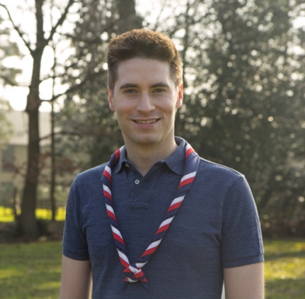

**Sam Morris**, Chief Commissioner of England

## How to apply

Process

Thank you for your interest in volunteering. On the following pages you will find a role description and the person specification. The County Commissioner nomination and application forms are on pages 15 and 16.

You can apply for the role yourself using the application form, or nominate someone else using the nomination form. Nominated people are under no commitment to apply unless they wish to. An online version of the form is available at: [https://www.scouts.org.uk/volunteer/volunteer-vacancies/](about:blank)

Shortlisting will be based solely on the information provided by each candidate in their application form. All applications should address the requirements of the role, as laid out in the role description and person specification.

#### Key dates

The closing date for applications is 12 noon on Sunday 3rd October 2021.

Interviews will be held in mid October 2021.

#### Further information

For more information, or for an informal chat about this vacancy, please contact: Graham Woolley - Regional Commissioner, East of England, Email: [Graham.Woolley@scouts.org.uk](mailto:Graham.Woolley@scouts.org.uk) or mob: 07733-138961

o*r* Kathryn Andrews - Area Growth & Development Manager (Greater London & East of England)

Email: Kathryn.andrews@scouts.org.uk

## Mark HarrisonWhy would I want to volunteer as a County Commissioner in Scouts?

So what’s in it for me you’re wondering? Whilst volunteering as a County Commissioner can be challenging at times, it is also incredibly rewarding and here’s why, according to our current team of County Commissioners in Team England…

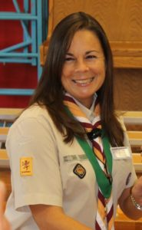

As a County Commissioner you will be able to really develop and hone your leadership skills by managing teams of remote volunteers across the breadth of West Yorkshire. Leading and managing volunteers provides so much more opportunity and experiences than with employees, what you can gain by doing this really well can be a great asset for your professional life as well as in Scouts. The issues and challenges that you find ways to tackle will stretch you as an individual and as a leader and you’ll find yourself discovering new things that you are capable of achieving.

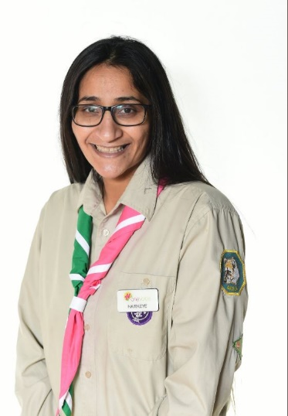This role is all about people and one of the incredible benefits of volunteering in any role in Scouts, but even more so as County Commissioner, is the teams of people you get to work with. You will inherit an incredible team of dedicated people leading Scouting in West Yorkshire, from District Commissioners who manage Scouting on a local level, to the people delivering high quality training for our Scout Leaders. As County Commissioner you get to inspire, motivate, shape and develop this team, building friendships and establishing a sense of camaraderie focused around our mission for young people.

If you get a kick out of seeing things happen, achieving success and making a positive impact to a wide audience then the County Commissioner role definitely provides all of that. In this role you will get to see the difference that Scouts makes to so many young people’s lives across a large area, helping them developing skills for life, fostering friendships and providing so many incredible and unforgettable experiences.

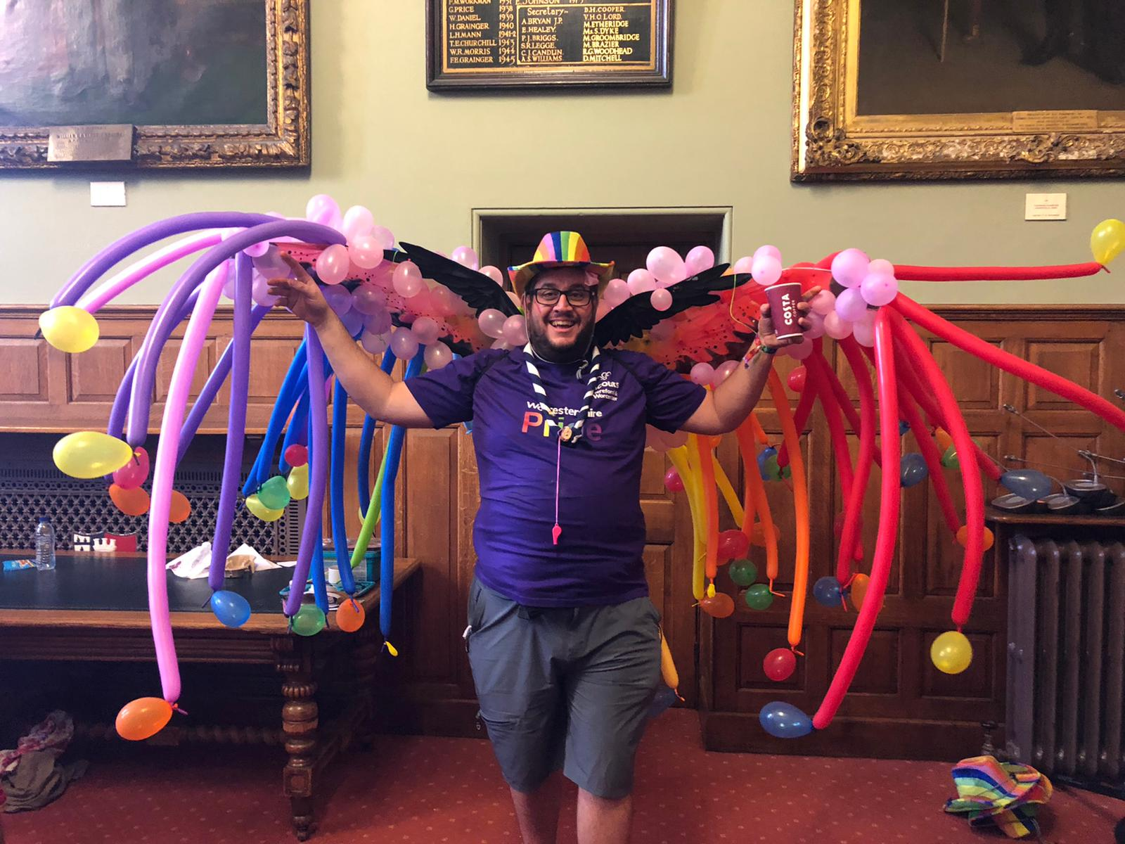As a County Commissioner you have an important role to lead the progress of our strategy. One such element of our strategy where County Commissioners play a leading role is in the provision of our Scouting programme to those harder to reach communities and groups of young people who might not normally have the option to take part. It will be your role to help lead our efforts to do this in West Yorkshire. It is an exciting time to take up the reins and support this work to achieve our ambitious goals for new young people.

And if you’re reading this thinking that it all sounds quite exciting and something you’d quite enjoy doing, but maybe you’re worried about the timing or you might think there is someone else who would be better for the role, ask yourself if not me, then who? If not now, then when?

## The role - County Commissioner

**Outline:**

The County Commissioner is a key volunteer leadership role within Scouting with responsibility for providing outstanding management and support for the eight Districts within the County. The primary focus for the County Commissioner is to ensure that Scouting is able to reach every young person in the County; open to all regardless of faith, colour or social background, because we believe Scouting has the ability to change lives. This is achieved by leading the team of eight District Commissioners, and other County appointments as well as working with the Regional Services Team (employed staff) to provide enough places to meet the demand for Scouting, and by ensuring that every youth member has access to a high-quality balanced programme that is challenging, relevant and rewarding.

|  |  |
| --- | --- |
| Appointed by: | Regional Commissioner for East of England, via a search group process responsible to the UK Headquarters Appointments Advisory Committee |
| Responsible to: | Regional Commissioner for East of England |
| Responsible for: | District Commissioners, Deputy County Commissioners, Assistant County Commissioners, County Training Manager, and all other County appointments, however it is expected that line management for other roles are delegated to Deputies/Assistants. |
| Main contacts: | Deputy County Commissioners, Assistant County Commissioners, County Chairman, County Network Scout Commissioner, members of the County Executive Committee and its subcommittees, District Commissioners, County Training Manager, County Scout Active Support Managers, members of the Regional Services Team, other County Commissioners in the Region, Chief Commissioners of England, members of the local community, schools and other youth organisations in the County. |
| Key tasks: | * Ensure that every Beaver Scout Colony, Cub Scout Pack, Scout Troop, Explorer Scout Unit and Scout Network within the County is able to deliver a high-quality programme which is challenging, relevant and rewarding for every young person * Provide proactive line management, including coaching, mentoring and guidance to District Commissioners as well as other adult volunteers in the County who directly report to you including setting objectives for their work, holding regular one-to-one meetings and reviews. * Build and maintain a sense of County team by holding regular team meetings with the District Commissioners, Deputy and Assistant County Commissioners, County Training Manager and other appropriate volunteers within your County team to collaborate and provide peer support. * Lead a safe, open and transparent culture around keeping young people and adults safe through our Yellow Card and key policies. * Ensure the timely recruitment and appointment of new District Commissioners where required and ensuring that interim arrangements are put in place for any vacant posts. * Together with the District Commissioners, agree the priorities for the County and produce a plan to deliver these to meet The Scout Association’s vision and strategic objectives. * Ensure that problems within the County are resolved so that an effective volunteering culture is encouraged and District Commissioners and Group Scout Leaders feel supported to deal with challenging issues, including complaints in a timely manner. * Ensure that the County has an adequate team of supported and appropriate adults working effectively together and with others to meet the Scouting needs of the area. * Ensure that problems within the County are resolved so that excellent Scouting is provided to young people in the County. * Act as an ex-officio trustee as a member of the County Executive Committee, and an ex-officio member of the Council of The Scout Association. * Play an active part within the East of England regional team by attending monthly Team catch-up calls and 3x Team meetings per year, led by the Regional Commissioner. There are also twice yearly Team England meetings for all County Commissioners to contribute to the development of Scouting within England as part of the Headquarters team. |
| Appointment requirements: | * County Commissioners are required to validate the learning for our manager and supporter volunteer training scheme, completion of which is recognised through the achievement of a Wood Badge for the County Commissioner role. As a key leadership position within Scouts we expect new County Commissioners to set a strong example and complete this required training within their first year. * County Commissioners must be eligible for charity trustee status (as a member of the County Executive Committee). * It is expected that whilst volunteering for this role you will undertake regulated activity. * County Commissioners are also expected to actively contribute as a member of their regional team and Team England, this includes attending between three to six regional team meetings and two All Team England meetings per year. As an ex-officio member of the Council of The Scout Association, County Commissioners are expected to vote on matters presented to Council including elect trustees to the Board and attend the Annual General Meeting, usually held on the first weekend in September. |
| Terms of appointment: | The initial length of appointment is at the discretion of the Regional Commissioner, through discussion with the appointee, and is usually for a period of three years initially up to a maximum of five before a formal appointment review. County Commissioners may complete a maximum of two terms of five years, so no more than a total of ten years in the role. Renewal and continuation of appointment is at the discretion of the Regional Commissioner and appointment reviews may be conducted at any time at the request of the role-holder and/or Regional Commissioner. |

**Note:** Many of the tasks for which the County Commissioner is responsible may be delegated to others in the County, including a Deputy County Commissioner, if appointed. Whilst the new appointee will inherit an existing team of volunteers in key County appointments, it is expected that new County Commissioners will review and reorganise their team’s objectives and roles as they see fit.

#### For more information about the role

Interested candidates are also encouraged to review Factsheet FS330074 available online at: [https://members.scouts.org.uk/factsheets/FS330074.pdf](about:blank) which provides more information about the role of the County Commissioner, structured around the six key areas of leadership and management.

## Norfolk Scouts

In Norfolk County, there are 8 Districts, made up of 109 Groups. Norfolk Scouts’ total membership is currently 6,950, which includes:

* 1087 Beaver Scouts (6 - 8 year olds)
* 1630 Cub Scouts (8 - 10 ½ year olds)
* 1535 Scouts (10 ½ - 14 year olds)
* 502 Explorer Scouts (14 – 18 year olds)
* 56 Network members (18 – 25 year olds)
* 2140 Adults (18+ year olds).

## The current vacancy

We’re currently looking for a County Commissioner. This is a management role, and we need someone who can provide leadership, motivation and guidance to our other adult volunteers.

The management structure of Scouting is as follows:

County Commissioners support volunteers and other managers, known as District Commissioners, who in turn support the managers of local Scout Groups. Adults at every level need support to ensure that they are motivated, inspired and focused on providing first-class Scouting. A good manager thanks other volunteers for their hard work, and helps to make sure that they feel happy and supported, week after week.

The County Commissioner will also provide direction for the County, and will help others see the bigger Scouting picture through solid leadership.

We believe that everyone in management roles within Scouting should adopt an approach that combines the skills of both leadership and management.

In Norfolk, there are several key tasks and activities which are carried out by the County Commissioner and county’s volunteer leadership team which would form part of the role and fall within the new County Commissioner’s scope to review, adapt and delegate accordingly. Some of these are carried out by the current County Commissioner and some are delegated to Deputy or Assistant County Commissioners. The important point here is that we don’t expect the County Commissioner to be a super-hero and do all of this, or devote every hour of the day to the role.

## Core Skill Areas

### We’ve identified six core skill areas that make a good Scouting manager:

### 1. Providing direction

A good County Commissioner will create a vision for Scouting in their County, and provide clear leadership to implement that vision.

2. Working with people

It is vital that a County Commissioner can create team spirit amongst the other volunteers they work with, and can form effective working relationships based on trust and the fundamental principles of Scouting:

* integrity
* respect
* care
* belief
* cooperation

3. Achieving results

Good County Commissioners ensure that goals are achieved, plans are seen through to completion, and that good relationships are maintained within and between Scouting Districts. Forging links within the local community is also an important aspect of development.

4. Enabling change

It is important for County Commissioners to encourage volunteers to think of creative ways to improve Scouting across the County. They should then provide the support to implement appropriate changes.

5. Using resources

A good County Commissioner will ensure that information and resources are available, helping volunteers across the County to continue to provide excellent Scouting opportunities to young people.

6. Managing time and personal skills

A good County Commissioner should use their time effectively, and be willing to continue to learn and improve their skills.

## Person specification

|  |  |
| --- | --- |
| Knowledge and experience: | |
| Ability to lead, manage and motivate people in a voluntary environment. | Essential |
| Understanding of the challenges of working in the voluntary sector | Desirable |
| Experience of working with young people and/or community work with adult groups | Desirable |
| Experience of volunteering in a manager/supporter role in Scouting (e.g. Group Scout Leader, District Commissioner or other District/County role) | Desirable |
| Skills and abilities: | |
| Excellent ability to communicate effectively, orally and in writing including ability to speak and present publicly in a clear, articulate and motivating way | Essential |
| Ability to provide advice and guidance effectively to others | Essential |
| Ability to provide inspirational strategic leadership for the County | Essential |
| Ability to contribute to strategy development and identify practical actions to achieve strategic objectives. | Essential |
| Ability to effectively chair meetings. | Essential |
| Can build, maintain and facilitate effective working relationships with a wide range of people | Essential |
| Ability to enable others to identify issues, clarify objectives, develop attainable objectives and gain the necessary skills and confidence to work as an effective team | Essential |
| Ability to negotiate compromises | Essential |
| Plans, manages and monitors own tasks and time | Essential |
| Can construct and implement long-term plans that improve and expand the Scouting offered to young people, and identify any training, resources and other needs required to undertake this work | Essential |
| Ability to use technology, especially mobile email, to carry out a range of tasks (confident in Microsoft Word, Excel and PowerPoint). | Essential |
| Personal qualities: | |
| An understanding of the needs of adult volunteers | Essential |
| Flexible approach | Essential |
| Self-motivated | Essential |
| Able to work as part of a team and promote good teamwork | Essential |
| Resourceful, energetic and enthusiastic about the job | Essential |
| Acceptance of the fundamentals of the Scout Movement | Essential |

## Induction for new County Commissioners

Induction plan delivered by the Regional Services Team

New County Commissioners will receive a series of face to face and remote interactions with the Area Growth & Development Manager, in conjunction with the Regional Commissioner, as part of a structured induction for the role. These interactions will also include an opportunity to develop a plan of action in the role with dedicated support from staff within the Regional Services Team to implement actions around developing and growing Scouting in the County.

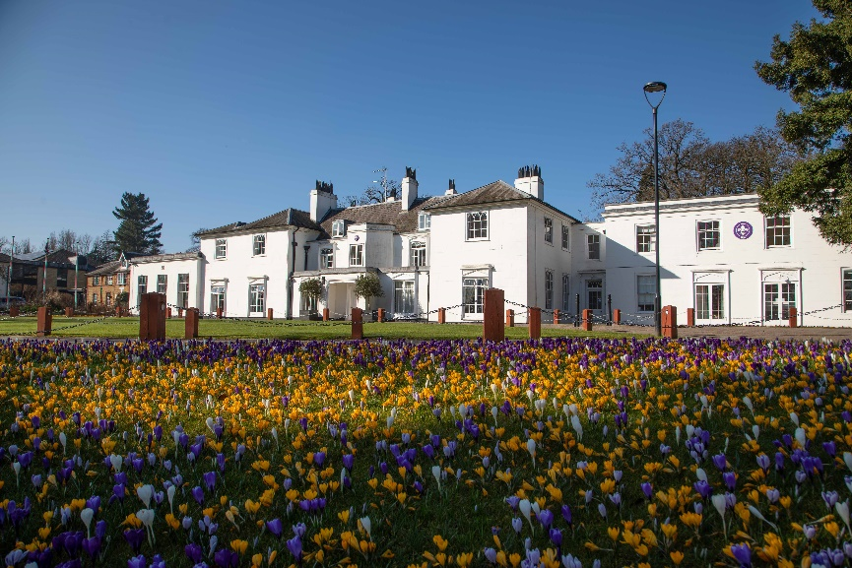Headquarters Volunteer Induction Days

County Commissioners are appointed by UK Headquarters to lead Scouting in their assigned County, and as such are a key part of the Headquarters Team, working in partnership with staff colleagues employed by the national charity, who are responsible for managing a range of nationally delivered services for local Scouting. New County Commissioners are invited to attend a two-day Headquarters induction at The Scouts’ national headquarters at Gilwell Park, London where you will have the chance to meet with key staff colleagues to put faces to names and explore the support available to you as part of the wider Headquarters team.

#### The Regional Services Team

The Regional Services Team is part of the UK Headquarters staff team within the Member Support Department, with field-based staff who cover the eight English regions. Teams of Growth & Development Officers, Senior Growth & Development Officers and Area Growth & Development Managers work alongside Group Scout Leaders, District, County and Regional Commissioners, as well as Assistant Regional Commissioners (Growth) to help open new sections, units and groups, provide tools to help existing groups to grow, provide training on adult recruitment, and support the induction of new volunteer managers in Scouting.

The Regional Commissioner is a key link between the Regional Services Team and local Scouting. Through close working and effective communication, the Regional Commissioner will develop plans with you and the other County Commissioners in the team to ensure the best use of resources to achieve Scouting’s goals for the region, as agreed with the Chief and Deputy Chief Commissioner of England. One Area Growth & Development Manager manages the staff team for both the North West and North East regions and works closely with both Regional Commissioners. The Area Growth & Development Manager is line managed by the National Regional Services Manager.

## About Scouts

Overview of Scouting

We are the UK’s biggest mixed youth organisation. We change lives by offering 6 to 25 year olds fun and challenging activities, unique experiences, everyday adventure and the chance to help others so that we make a positive impact in communities.

Scouts helps children and young adults reach their full potential. Our members gain valuable skills for life including teamwork, time management, leadership, initiative, planning, communication, self-motivation, cultural awareness and commitment. We help young people to get jobs, save lives and even change the world.

What do Scouts do?

Scouts take part in a wide range of activities as diverse as kayaking, abseiling, expeditions overseas, photography, climbing and zorbing. As a Scout you can learn survival skills, first aid, computer programming or even how to fly a plane. There’s something for everyone. It’s a great way to have fun, make friends, get outdoors, express your creativity and experience the wider world.

What do volunteers do?

This everyday adventure is only possible thanks to our team of adult volunteers, who support Scouts in a wide range of roles from working directly with young people, to helping manage a local community based Group, to being a charity Trustee. We help volunteers get the most out of their experiences at Scouts by providing opportunities for adventure, training, fun and friendship.

Our award winning training scheme for volunteers means that adults get as much from Scouts as young people. Our approach focuses on what you want to get out of volunteering with Scouts, while respecting how much time you can offer. Over 90% of Scout volunteers say that their skills and experiences have been useful in their work or personal life.

Key facts and figures

The Scout Association is a UK charity founded in 1907 and now boasts a membership of over 620,000 young people and adult leaders. We are the largest mixed youth movement in the UK. Scouting activity is delivered through 7,000-plus community based Scout Groups nationwide.

Scouting is widely recognised and is one of the most trusted charities in the UK, giving it a significant level of influence and responsibility. Scouting’s greatest strength lies in its grass roots. It is locally that Scouting is best able to identify and work directly with young people most in need.

We believe that through the everyday adventure of Scouting, young people and adult volunteers regularly experience new challenges that enrich and change their lives.

The current focus for the Trustees and those in Scouting in the UK is delivering our strategic vision.

## Our strategic plan

#### By 2023 (now extended to 2025) we will have prepared more young people with skills for life, supported by amazing leaders who deliver an inspiring programme. We will be growing, more inclusive, shaped by young people and making a bigger impact in our communities.

Society is changing. In often fragmented communities, the pressures and expectations on young people are increasing. The future is uncertain. Scouts has never been so important in helping young people prepare for the future, developing the skills they need to succeed in a changing world. Each week almost half a million young people enjoy fun, friendship and outdoor adventure. They develop a sense of optimism and strong values as well as the leadership and team working skills that are more valuable today than ever.

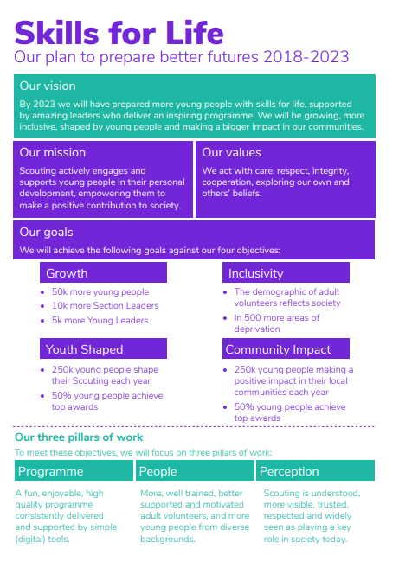Our movement achieves remarkable things. We have continued to grow for 13 consecutive years. Our previous plan, Scouting for All, inspired new Groups and sections to start in an additional 834 areas of deprivation since 2013. We now help over 462,000 young people aged 6-18 (including 102,000 girls) get the best possible start in life. Our social action campaign, A Million Hands, has enabled over 200,000 young people to make a positive contribution in their local communities.

Now we want to go further. Skills for Life is a strategy that supports and empowers our volunteers who are the people that make Scouts a reality. It’s a strategy to bring communities together and contribute towards a better society. But most of all, it’s a strategy for young people. They deserve the best skills, the best support, and the best possible futures

‘I believe that Scouts empowers young people. It gives them skills to achieve the remarkable, and opportunities to develop a deeper understanding of the rapidly changing world.’ Tim Kidd, UK Chief Commissioner

## Scouting’s fundamentals

#### Our mission

Scouting exists to actively engage and support young people in their personal development, empowering them to make a positive contribution to society.

#### Our values

As Scouts, we are guided by these values:

##### Integrity

##### Respect

##### Care

##### Belief

##### Co-operation

Further information on our fundamentals, including details of our values, are provided on our website at [http://scouts.org.uk/about-us/key-policies/fundamentals-of-scouting/](about:blank)

## Scouting’s key policies

In common with all members in Scouting, County Commissioners are required to promote and follow our key policies. The policies cover:

Fundamentals of Scouting

Religious policy

Equal opportunities

Safety

Development

Child protection

Data Protection

These policies are fully explained on our website at [http://scouts.org.uk/about-us/key-policies/](about:blank)

## Nomination Form

If you think you know the right person for this County Commissioner role, please complete the nomination form below. Nominating an individual does not commit them to applying, but, if they choose to, they will be required to complete a more thorough application form.

|  |  |
| --- | --- |
| Nominee’s details | |
| Name |  |
|  |  |
| Telephone number |  |
|  |  |
| Email address |  |
|  | |
| Please outline why you felt motivated to nominate this person for the role of County Commissioner: | |
|  | |
|  | |
| Nominated by |  |
|  |  |
| Telephone number |  |
|  |  |
| Email address |  |
|  |  |
| Please return this form to: | Graham Woolley |
|  |  |
| The closing date for receiving nominations is: | 12 noon on Sunday 3rd October 2021 |

## 

## Application Form

If you are interested for applying for this County Commissioner role, please complete the application form below.

|  |  |
| --- | --- |
| Name |  |
|  |  |
| Telephone number |  |
|  |  |
| Email address |  |
|  |  |
| Please outline why you want to apply for the role of County Commissioner: | |
|  | |
|  |  |
| Please briefly explain why you would be suitable for this role, including professional and voluntary experience, within or outside Scouting (refer to role description): | |
|  | |
|  |  |
| Please describe the skills you would bring to this role (refer to person specification): | |
|  | |
|  |  |
| Please return this form to: | Graham Woolley |
|  |  |
| The closing date for receiving nominations is: | 12 noon on Sunday 3rd October 2021 |